**AppDynamics**

*Application Analysis*

# **Introduction**

AppDynamics is a full-stack application performance management and IT operations analytics company based in San Francisco.

AppDynamics Application Analytics helps you to answer business questions about your application such as:

* How many users experienced failed checkout transactions in the last 24 hours, how much revenue was lost because of these failures, and how is that revenue distributed across different product categories?
* What is your revenue for the day for a geographical region?
* What was the revenue impact by product category associated with the two marketing campaigns we ran last week?

As a separately licensed product line for the AppDynamics Application Intelligence Platform, AppDynamics Application Analytics enhances and extends AppDynamics APM, EUM, and other monitoring product modules.

# 

# **Project Summary**

| **Website** | [**https://www.appdynamics.com/**](https://www.appdynamics.com/) |
| --- | --- |
| **Organization/**  **Foundation Name** | **Cisco** |
| **License** | Infrastructure-based License (IBL) model and an Agent-based License (ABL) |
| **Open/Proprietary** | **Proprietary** |
| **Source Path(if open source)** | **//the path to the source code** |
| **Brief Description** | AppDynamics is a full-stack application performance management and IT operations analytics company based in San Francisco. |

**Project Details**

**Features:**

### **1.Application Performance Monitoring**

## Streamline how you visualize and monitor all components of your application with a single unified platform. Pinpoint bottlenecks to proactively remediate performance issues and sustain optimal performance. Align IT with business leaders to create exceptional user experiences and drive business outcomes.

### **2.Ensure Application Availability**

## Our fully integrated solution uses machine learning to provide automated anomaly detection and root cause analysis to improve your team’s efficiency while reducing MTTR, app downtime, and SLA breaches. Proactive alerting gives IT the clarity to find and resolve issues before they impact end users.

### **3.Monitor and Manage Hybrid Environment**

## Simplify your migration to the cloud with performance insights that clarify real-time impact on business and application performance. Gain a holistic view of both the cloud and on-premises components of your distributed application infrastructure with a flexible solution that helps you quickly mitigate issues and accelerate performance

## 

**Architecture**

*ABAP Agent comprises multiple components and uses various AppDynamics agents and APIs to enable relevant functionality. This page provides a high level overview of the solution architecture, isolated data flows, and prerequisites.*

## Architecture Diagram:

The following diagram depicts all components along with their interactions:

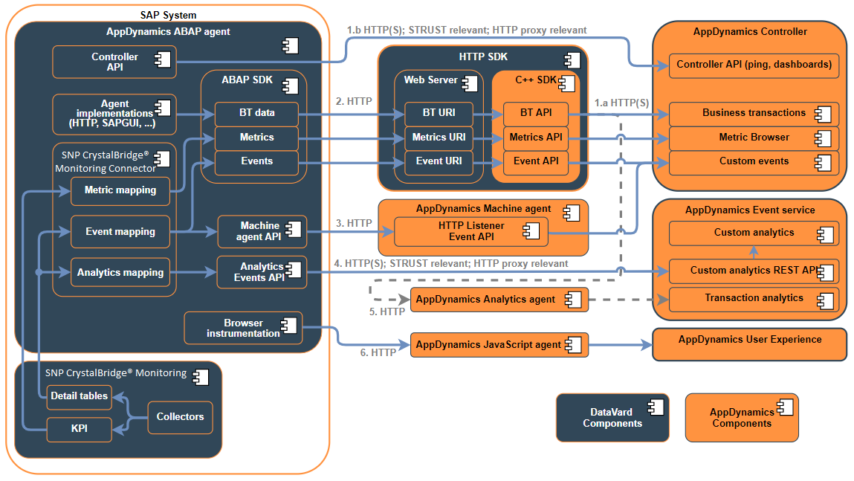

## 

## 

## **Current Usage**

‘

*Companies using AppDynamics APM for Application Performance Management include: Exxon Mobil, a United States based Oil, Gas and Chemicals organization with 64000 employees and revenues of $276.69 billion, The Hongkong and Shanghai Banking Corporation, a Hong Kong based Banking and Financial Services organization with 70000 employees and revenues of $255.23 billion, Deutsche Telekom, a Germany based Communications organization with 216109 employees and revenues of $128.90 billion, Comcast Corporation, a United States based Communications organization with 168000 employees and revenues of $103.56 billion, Mercedes-Benz, a Germany based Manufacturing organization with 152000 employees and revenues of $93.00 billion and many others.*

## 

## 

## 

## 

## **Technical Details**

1. **Use a thread pool to invoke the REST APIs.** 
   * This way the customer will have control on the concurrency. This should help to sustain 10 concurrent requests on the server side, getting the best performance.
2. **Decrease the frequency of the job.**
   * For example, run the job every 5 minutes rather than every one minute.
   * We recommend restricting the number of Metric data points returned per REST call to less than 50K.

*AppDynamics auto-discovers the flow of all traffic requests in your environment and dynamically creates a topology map to visualize performance across the application ecosystem. Closely follow the digital experience of your users and get ahead of issues with web, mobile or synthetic transaction monitoring.*

### 

### **Project comparison**

#### **Dynatrace:**

AppDynamics and Dynatrace are two application performance monitoring systems that are both cloud-based and both use AI to project resource shortages and raise alerts. The two systems are very similar but the big difference is the price – AppDynamics starts at $3,600 per year and Dynatrace costs about $10,000 per year.

#### **New Relic:**

AppDynamics is available in a number of installation types and can be deployed as a SaaS platform, on-premises, or hybrid platform. On the other hand, New Relic is only available through SaaS. If you're looking for flexible deployment options then AppDynamics is the product for you

#### **Datadog:**

Since Datadog is aimed at monitoring infrastructure at scale, it's used primarily by mid-sized companies and large enterprises. It is also favored by DevOps and IT to address cloud and infrastructure performance. AppDynamics has features that connect application performance to customer experience and business outcomes.

#### **Microsoft Azure Application Insights:**

Application Insights is an extension of Azure Monitor and provides Application Performance Monitoring (also known as “APM”) features. APM tools are useful to monitor applications from development, through test, and into production in the following ways: Proactively understand how an application is performing.

#### **Amazon CloudWatch:**

Developers describe Amazon CloudWatch as "*Monitor AWS resources and custom metrics generated by your applications and services*". With Amazon CloudWatch, you gain system-wide visibility into resource utilization, application performance, and operational health. Programmatically retrieve your monitoring data, view graphs, and set alarms to help you troubleshoot, spot trends, and take automated action based on the state of your cloud environment. On the other hand, AppDynamics is detailed as "*Application management for the cloud generation*". AppDynamics develops application performance management (APM) solutions that deliver problem resolution for highly distributed applications through transaction flow monitoring and deep diagnostics.

### 

**What is the importance of AppDynamics?**

*AppDynamics provides real-time visibility across distributed environments and delivers insights to IT and developer teams based on correlated data collected across infrastructures, applications, networks, and databases. Monitor Amazon Web Services-based applications including microservices and Docker.*

**References**

[**https://www.appdynamics.com/**](https://www.appdynamics.com/) **:**

Information regarding the application

[**https://en.wikipedia.org/wiki/AppDynamics**](https://en.wikipedia.org/wiki/AppDynamics) **:**

history and information for appdynamics

[**https://docs.appdynamics.com/appd/4.5.x/en/appdynamics-essentials/license-management**](https://docs.appdynamics.com/appd/4.5.x/en/appdynamics-essentials/license-management) **:**

information regarding the licensing and agreements

**--------------------End ---------------------**